NAME: RAJA RAYYAN AMEER
REG. NO.: 23-CP-25
SECTION: ALPHA
SUBJECT: ML&AI
DEPARTMENT: COMPUTER ENGINEERING
TEACHER: SIR SHAHID
LAB 3:
Task: Train a Univariate using Linear Regression Model, first using the Formulas, and then use the Built in Libraries and Functions. Generate the Dataset with Dummy Values using Chat GPT.
Program Code:
import pandas as pd
import numpy as np
import matplotlib.pyplot as plt
print("METHOD 1: ")
df = pd.read_csv("House Price Univariate Dataset.csv")
x = df["Size_sqft"].values
y = df["Price"].values
x_mean = np.mean(x)
y_mean = np.mean(y)
m = np.sum((x - x_mean) * (y - y_mean)) / np.sum((x - x_mean)**2)
c = y_mean - (m * x_mean)
print("Slope: ",m)
print("Intercept: ",c)
y_pred = (m * x) + c
mse = np.mean((y - y_pred)**2)
print("MSE: ",mse)
ss_error = np.sum((y - y_pred)**2)
ss_total = np.sum((y - y_mean)**2)
r2 = 1 - (ss_error / ss_total)
print("R2: ",r2)
# Plot 1: Regression Line (Method 1)
plt.figure(figsize=(10, 6))
plt.scatter(x, y, alpha=0.5, label='Actual Data')
plt.plot(x, y_pred, color="red", linewidth=2, label='Regression Line')
plt.title("Method 1: Regression Line (Manual Calculation)")
plt.xlabel("Size (sqft)")
plt.ylabel("Price")
plt.legend()
plt.grid(True, alpha=0.3)
plt.show()
# Plot 2: Residual Plot (Method 1)
residuals = y - y_pred
plt.figure(figsize=(10, 6))
plt.scatter(x, residuals, alpha=0.5)
plt.axhline(y=0, color='red', linestyle='--', linewidth=1)
plt.title("Method 1: Residual Plot (Manual Calculation)")
plt.xlabel("Size (sqft)")
plt.ylabel("Residuals")
plt.grid(True, alpha=0.3)
plt.show()
print("METHOD 2: ")
from sklearn.linear_model import LinearRegression
from sklearn.metrics import mean_squared_error, r2_score
from sklearn.model_selection import train_test_split
x2 = df[["Size_sqft"]].values
y2 = df["Price"].values
x_train, x_test, y_train, y_test = train_test_split(x2, y2, test_size=0.2, random_state=42)
model = LinearRegression()
model.fit(x_train, y_train)
y_pred2 = model.predict(x_test)
print("Slope: ", model.coef_)
print("Intercept: ", model.intercept_)
print("MSE: ", mean_squared_error(y_test, y_pred2))
print("R2: ", r2_score(y_test, y_pred2))
sorted_idx = x_test.flatten().argsort()
x_test_sorted = x_test[sorted_idx]
y_pred2_sorted = y_pred2[sorted_idx]
# Plot 3: Regression Line (Method 2)
plt.figure(figsize=(10, 6))
plt.scatter(x_test, y_test, alpha=0.6, label='Test Data')
plt.plot(x_test_sorted, y_pred2_sorted, color="red", linewidth=2, label='Regression Line')
plt.title("Method 2: Regression Line (Scikit-learn - Test Data)")
plt.xlabel("Size (sqft)")
plt.ylabel("Price")
plt.legend()
plt.grid(True, alpha=0.3)
plt.show()
# Plot 4: Residual Plot (Method 2)
residuals2 = y_test - y_pred2
plt.figure(figsize=(10, 6))
plt.scatter(x_test, residuals2, alpha=0.6)
plt.axhline(y=0, color='red', linestyle='--', linewidth=1)
plt.title("Method 2: Residual Plot (Scikit-learn - Test Data)")
plt.xlabel("Size (sqft)")
plt.ylabel("Residuals")
plt.grid(True, alpha=0.3)
plt.show()
comparison = pd.DataFrame({
'Actual': y_test.flatten(),
'Predicted': y_pred2.flatten(),
'Error': y_test.flatten() - y_pred2.flatten()
})
print(comparison)

Output:
METHOD 1:
Slope: 150.127740964807
Intercept: 1061.490836211422
MSE: 444453128.0475126
R2: 0.9814157255695188
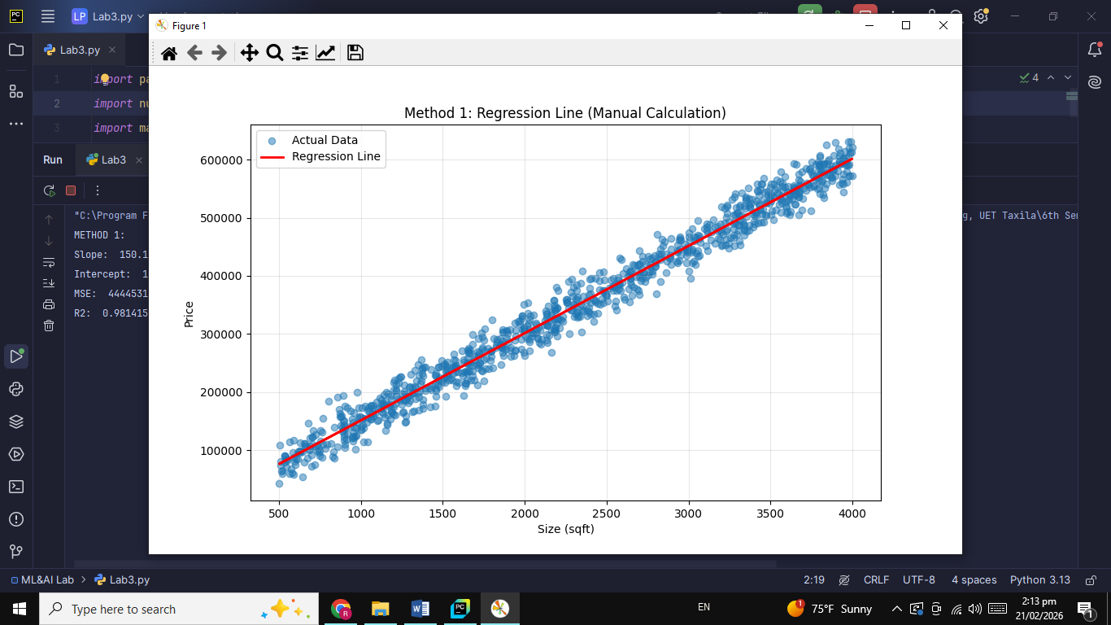
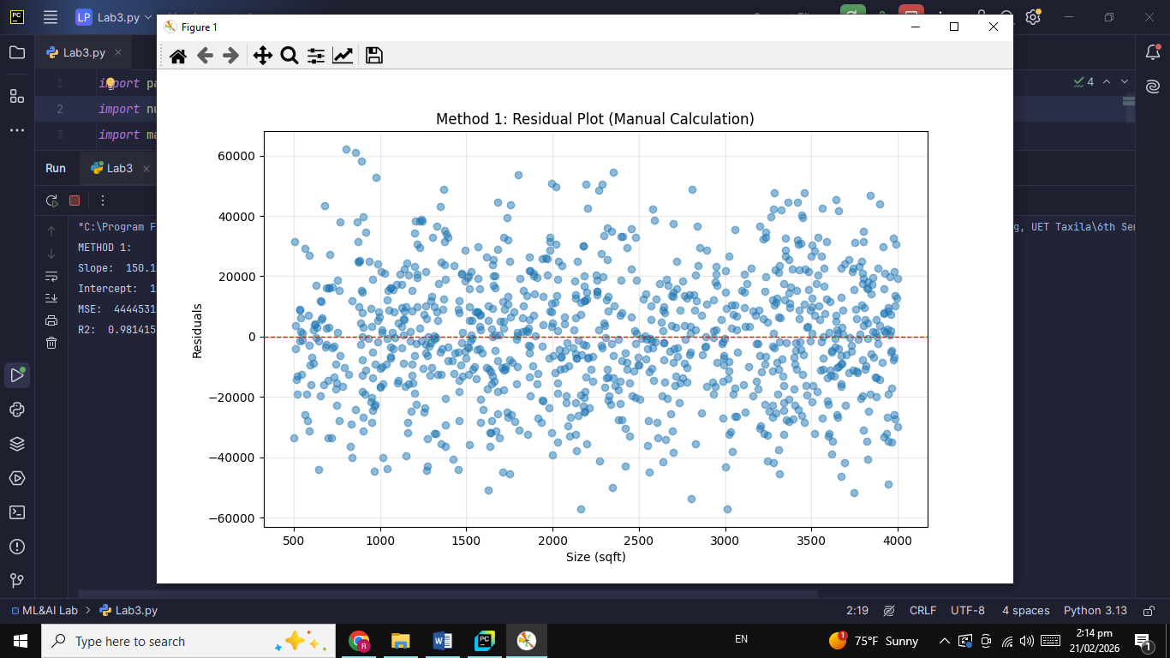
METHOD 2:
Slope: [149.8793306]
Intercept: 1387.1056232571136
MSE: 410287372.9507277
R2: 0.9828091497995461
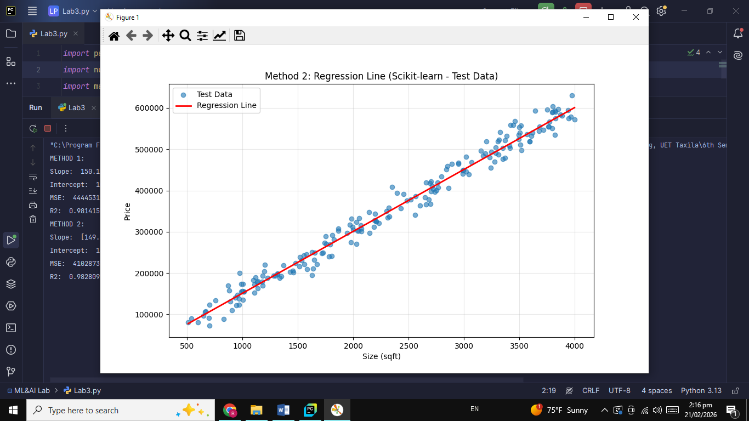
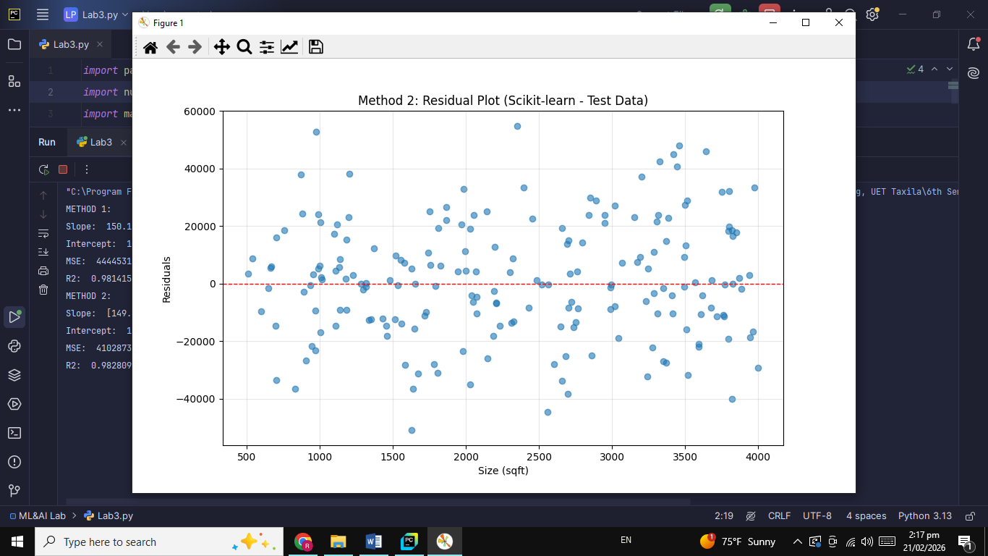

# | Actual | Predicted | Error
0 | 502812 | 513075.140300 | -10263.140300
1 | 593690 | 547697.265669 | 45992.734331
2 | 568115 | 519969.589507 | 48145.410493
3 | 536555 | 536156.557212 | 398.442788
4 | 273396 | 262626.778863 | 10769.221137
… | … | … | …
195 | 540016 | 543950.282404 | -3934.282404
196 | 603699 | 571528.079234 | 32170.920766
197 | 591076 | 571228.320573 | 19847.679427
198 | 156971 | 150666.918903 | 6304.081097
199 | 392026 | 369340.862252 | 22685.137748
[200 rows x 3 columns]
THE END

